**Hands-On Exercises: Authentication and Authorization in ASP.NET Core Web API Microservices:**

Ayushman Upadhyay 2230164

Hands-On Exercises: Authentication and Authorization in ASP.NET Core Web API Microservices

**Question 1:**

**Implement JWT Authentication in ASP.NET Core Web API**

**Scenario:** You are building a microservice that requires secure login.

You need to implement JWT based authentication.

**Steps:**

1. Create a new ASP.NET Core Web API project.
2. Add a `User` model and a login endpoint.
3. Generate a JWT token upon successful login.
4. Secure an endpoint using `[Authorize]`.

Solution **JwtAuthMicroservice** directory:

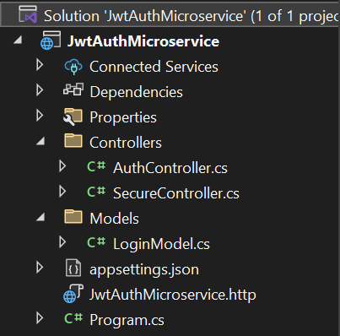

**Sample Output**

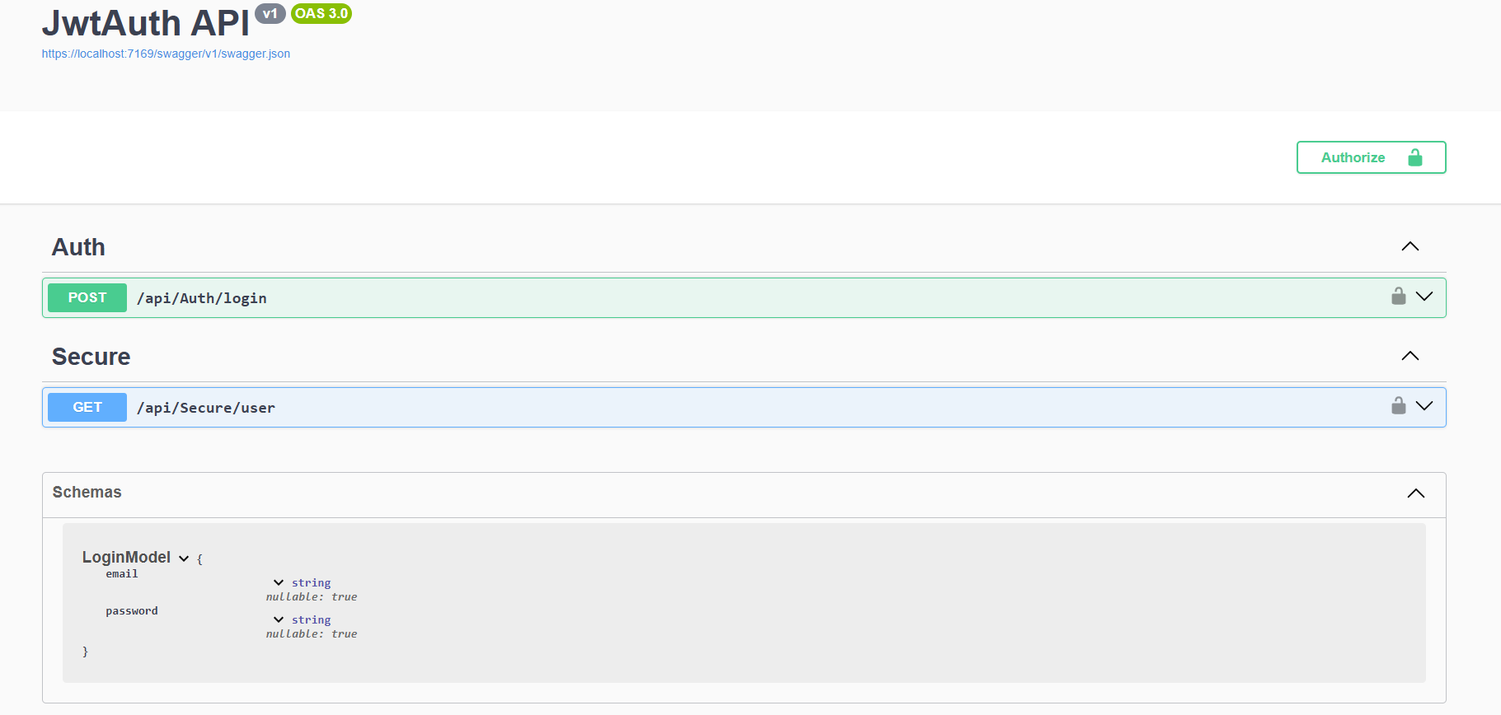

1. Login Endpoint

Endpoint: POST /api/Auth/login  
Request Body:

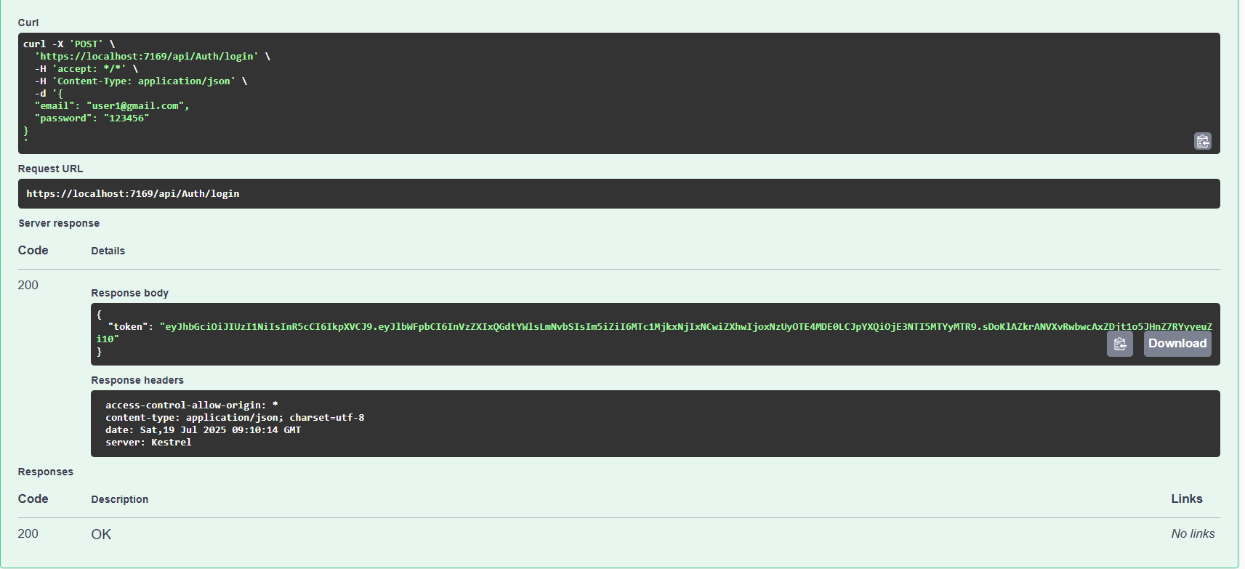

2. Access Secure Endpoint

Endpoint: GET /api/Secure

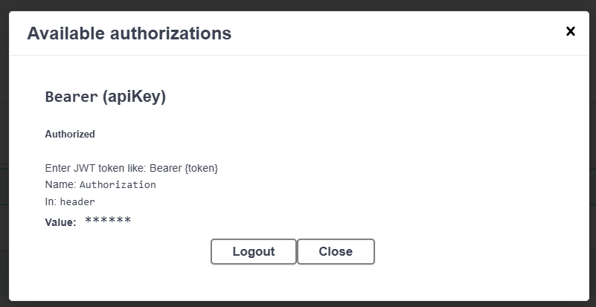

1. Endpoint: GET /api/Secure

